**Career Development Analysis Dashboard**

Date: [16th August 2024]

Author: [Dhrupal Patel]

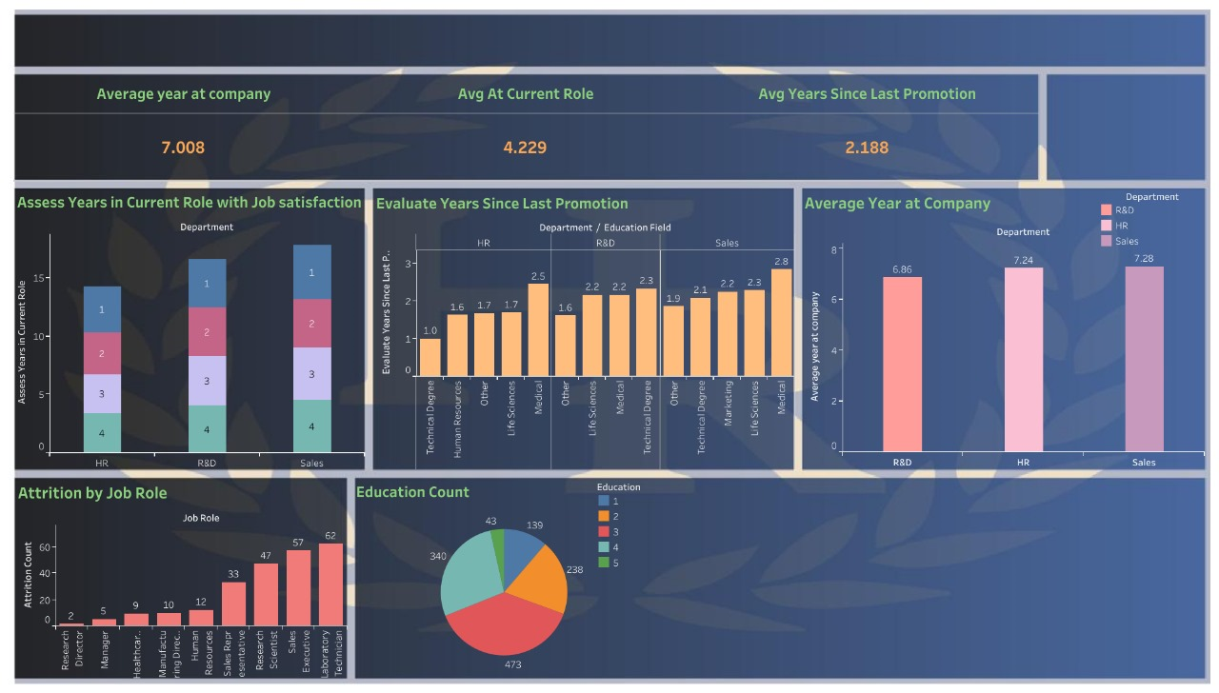

**1. Overview:**

The dashboard provides an analysis of employee metrics across different departments, focusing on tenure, time in current roles, years since last promotion, job satisfaction, and attrition rates. The data is segmented by department and education level, providing insights into various factors affecting employee retention and career progression.

**2. Key Metrics:**

* **Average Years at Company:**  
  The average tenure of employees at the company is **7.008 years**.
* **Average Years in Current Role:**  
  Employees have spent an average of **4.229 years** in their current roles.
* **Average Years Since Last Promotion:**  
  On average, employees have not been promoted in the last **2.188 years**.

**3. Detailed Insights:**

**A. Assess Years in Current Role with Job Satisfaction:**

* The stacked bar chart displays the relationship between years spent in the current role and job satisfaction across three departments: HR, R&D, and Sales.
* **HR:**  
  Most employees with lower tenure (1-4 years) show varied levels of job satisfaction.
* **R&D:**  
  Employees are relatively balanced across different levels of job satisfaction, with a slight concentration in mid-range tenure (3-4 years).
* **Sales:**  
  Similar to HR, job satisfaction is dispersed across different tenure levels, with more employees in the lower range.

**B. Evaluate Years Since Last Promotion:**

* The bar chart shows how long it has been since employees were last promoted, segmented by department and education field.
* **HR:**  
  Employees with technical degrees have waited the least time for promotions, while those with medical education waited longer.
* **R&D:**  
  There's consistency across all educational fields, with a slight peak for employees with medical backgrounds.
* **Sales:**  
  Employees with a medical background have waited the longest for a promotion (2.8 years), followed by life sciences (2.3 years).

**C. Average Year at Company:**

* The bar chart illustrates the average tenure across different departments:
  + **R&D:** Employees average **6.86 years** at the company.
  + **HR:** Employees average **7.24 years** at the company.
  + **Sales:** Employees average **7.28 years** at the company.

**D. Attrition by Job Role:**

* The attrition rate by job role is displayed in a bar chart:
  + **Sales Executives:** Highest attrition with **62** employees.
  + **Laboratory Technician:** Second highest attrition with **57** employees.
  + **Research Scientist:** Also significant with **47** employees.
  + Other roles such as Research Director and Healthcare Representative have lower attrition rates.

**E. Education Count:**

* The pie chart shows the distribution of employees by education level:
  + **Technical Degree:** **473** employees.
  + **Human Resources:** **340** employees.
  + **Other:** **238** employees.
  + **Medical:** **139** employees.
  + **Life Sciences:** **43** employees.

**4. Conclusions:**

* **Tenure & Promotions:**  
  The average tenure at the company is high, but the average years since last promotion suggest a potential bottleneck in career advancement, particularly in certain educational fields within the Sales department.
* **Job Satisfaction:**  
  Job satisfaction levels vary significantly by department and tenure, indicating areas where employee engagement strategies might be necessary.
* **Attrition:**  
  High attrition in Sales and technical roles like Laboratory Technicians could indicate issues that need addressing, such as job satisfaction, role fit, or external market conditions.
* **Education:**  
  The company has a diverse educational background among its employees, with a strong representation from technical degrees.